Circular Fashion: Making the Fashion Industry Sustainable
Peggy Blum
____________________________________________________
Instructor’s Guide

PREFACE

The Instructor’s Guide is designed to assist instructors teaching courses where Circular Fashion: Making the Fashion Industry Sustainable is utilized as a primary or supplemental textbook.
For each chapter, activities and assignments are provided to facilitate learning and to encourage students to develop new ideas and engage with their peers in class discussions. Some of these activities may require students to use technology, such as online search tools or PowerPoint or YouTube Creator software.
PowerPoint slide presentations for each chapter complement the concepts, theories, and terminology from the textbook. Instructors may use them as a guide to create weekly lecture presentations to meet the needs of their specific classes.
At the end of each part in the textbook, case studies provide an opportunity for students to analyze challenges and opportunities, and to evaluate circular solutions.
A sample syllabus is provided for use in a 15-week semester including one week of class reflection/final exam review and one week of final exams.

Week | Lecture Topic | Assignments/Activities | Readings
One | Evolution of the Fashion Industry  Challenges and Opportunities | Fashion Industry Timeline  Ranking Sustainability Issues | Introduction
Two | Part 1: Create  Developing a Circular Mindset | A Linear to Circular Think Tank | Chapter 01
Three | Design Thinking and Rethinking  Case Study:  Filippa K | Design with a Circular Intention | Chapter 02
Four | Part 2: Make  Materials | Biological or Technical Cycles and My Wardrobe | Chapter 03
Five | Processing | Virtual Watch Party:  River Blue | Chapter 04
Six | People and Production  Case Study:  Miranda Bennett Studio | Fashion Revolution #whomademyclothes Sweatshop Deadly Fashion Events | Chapter 05
Seven | Part 3: Market  Logistics and Transport | The Environmental Impact of Free Clothing Returns | Chapter 06
Eight | Retail | Garment Collection and Recommerce | Chapter 07
Nine | Marketing  Case Study: Veja | Social Media and Circular Fashion | Chapter 08
Ten | Part 4: Use/Care/Repair  Consumption | How to Wash, Care, and Mend Guide  Purchasing Journal Project  Consumer Manifesto | Chapter 09
Eleven | Industry Tools, Assessments, and Standards  Case Study: Patagonia | Circular Sleuths | Chapter 10
Twelve | Part 5: Renew  Clothing: End of Use | Remaking Fashion Exhibition | Chapter 11
Thirteen | Fashion Industry Collaboration and Innovation  Case Study:  Eileen Fisher | What Makes A Circular Leader?  How Do I Become a Circular Leader? | Chapter 12
Fourteen |  | Class Reflection and  Final Exam Review
Fifteen |  | Final Exam

ACTIVITIES AND ASSIGNMENTS

Introduction: The Evolution of the Fashion Industry

Assignment: Fashion Industry Timeline

Knowledge of the key reference points and events in the history of fashion lay the foundation for a deeper understanding of the present environmental and social issues of the industry and why sustainability is important for its survival.

Brief: Students can work individually or in groups. From a historical perspective, students should create a visual timeline of five to seven key events that were instrumental in contributing to the sustainability challenges and issues facing the fashion industry today. Timelines can be shared and presented in class for further discussion.

Deliverable: Each student or group of students should create one PowerPoint or Prezi slide.

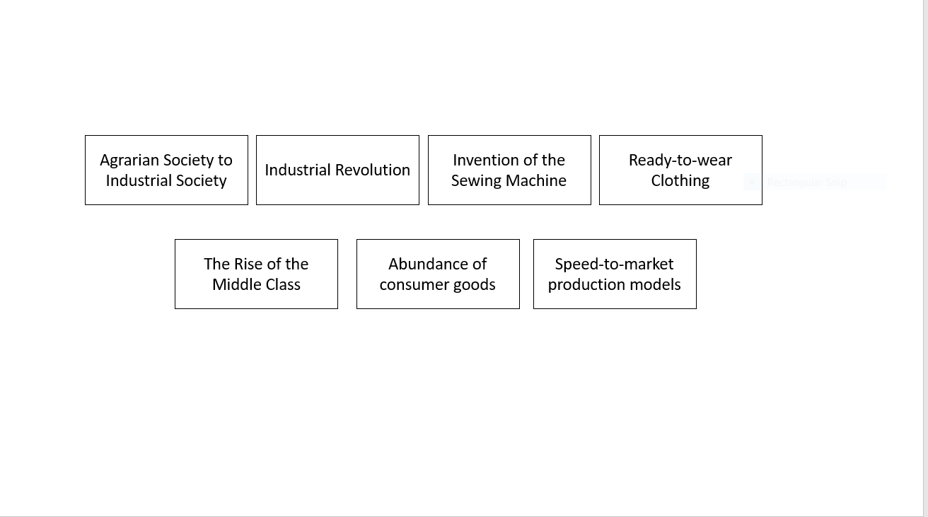

Assignment and Presentation: Ranking Sustainability Issues

Building on students’ knowledge of the industry from a historical perspective, encourage them to formulate a deeper understanding of the sustainability issues facing the industry today. Ranking issues allows students to arrange key themes according to their relative importance or urgency.

Discussion prompts: How do you view sustainability in the fashion industry? What are the key themes most important to you?

Brief: Students can work individually or in groups. Below are ten suggested themes related to sustainability and circular fashion.

WATER POLLUTION AND EXCESSIVE USAGE

GREENHOUSE GAS EMISSIONS

TOXIC
CHEMICALS

LAND AND SOIL DEGRADATION

ANIMAL RIGHTS AND WELFARE

OVER-CONSUMPTION AND OVER-PRODUCTION

LIVING WAGES AND WORKERS RIGHTS

SOCIAL AND LOCIAL COMMUNITY DEVELOPMENT
TEXTILE WASTE

SUPPLY CHAIN
TRANSPARENCY

Students should:
- Reflect on and discuss the themes
- Arrange the themes in order of importance in a pyramid shape on a separate sheet of paper; the most important theme should appear at the top, with the next two important themes on the second row, the next three on the third row, and four on the last row
- Glue the themes in place or take a photo of their completed work
- Present their work to share different perspectives and facilitate a class discussion
- Students may also do further research into their themes and present their findings to the class

Deliverable: Each student or group of students should present one completed sheet of themes in order of importance in a pyramid shape. Completed sheets can be displayed in a physical classroom space or on a virtual classroom wall, such as Padlet, for future reference.

PART 1: CREATE

Chapter 01: A Circular Mindset

Assignment and Presentation: A Linear to Circular Think Tank

Reframing mindsets invites “thinking systemically” about the current fashion system and the individual and collective roles of all stakeholders. This assignment is an opportunity for students of different majors, backgrounds, and perspectives to question and challenge each other on their assumptions and inspire them to help improve the fashion system through circularity.

Discussion prompt: How might we encourage consumers and the community to think and act for the long term?

Brief: Students should work in groups.
- Organize students into five groups, with each group including a variety of “specialists,” such as fashion and product designer, material and textile specialist, fashion buyer, retailer, business expert, service designer and specialist, consumer, social media and communication expert
- Ensure each team member has been assigned a “specialty” in the group
- Using the circular fashion model (pages 20-22) as a reference, ask each group to outline each team member’s role, the role of team members as a collective, the role of industry leaders, and the responsibility of each stakeholder in shifting from a linear to a circular fashion system

Deliverable: Each group of specialists should create a five to ten slide PowerPoint presentation or a five minute video highlighting the importance of the role and responsibility of every stakeholder in the fashion system to help shift from a linear to a circular fashion production model.

Chapter 02: Design Thinking and Rethinking

Assignment: Design with a Circular Intention

Transitioning to circular fashion design is one of the greatest challenges of our century. For designers, it means rethinking traditional approaches, retraining in new circular methods, and sharing knowledge about circular design practices.

Discussion prompt: How do fashion designers use circular design considerations to innovate the way they create new fashion products?

Brief: Students can work individually or in groups. Using the circular fashion design considerations (pages 32-41), and the list of designers below, invite students to explore the work of a circular fashion designer.
Students should:
- Explain the philosophy of a circular fashion designer
- Identify a circular fashion design consideration utilized in the designer’s work
- Select three to four examples of fashion products illustrating the circular design consideration in the designer’s work
- Explain how the circular design consideration is applied in each example

Circular Fashion Designers
Reet Aus
Miranda Bennett
Isabel Fletcher
Susanne Guldager
Lilah Horwitz
Christopher Raeburn
Vera De Pont
Zero Waste Daniel

Deliverable: Each student or group of students should present a research paper and/or a ten to twelve slide PowerPoint presentation to the class.

PART 2: MAKE

Chapter 03: Materials

Assignment: Biological or Technical Cycles and My Wardrobe

Based on the laws of nature, the Cradle to Cradle model recognizes two cycles within which materials flow in a closed loop: the biological cycle and the technical cycle. Understanding these cycles encourages students to consider the materials used in creating fashion products more carefully.

Discussion prompt: When designing or sourcing materials for the purpose of fashion design or purchasing designed goods, why is it important for a consumer to understand where the product and its materials will end up after use?

Brief: Students should work individually. Using the biological cycle and technical cycle chart (page 48) as a reference, students should select five to ten clothing or accessory items from their wardrobes and determine whether each item will end up in the biological or technical cycle after use. Students should:
- Select and photograph five to ten clothing or accessory items
- Check the care label of each item to determine its fabric content
- For each item (photograph), label the fabric content and whether it belongs in a biological or technical cycle
- Share the clothing items by posting in a virtual discussion forum or present in class for a reflection discussion

Deliverable: Students should produce five to ten photographs labeled with fiber content and indicating whether the item will end up in a biological or technical cycle after use.

Reflection: Are students surprised at the results? Will knowing where a clothing or accessory item may end up after use encourage them to read the care label before purchasing it? What cycle did students place items made of cotton and polyester blends in? Why are these items difficult to categorize?

Chapter 04: Processing

Assignment: Virtual Watch Party for River Blue

Film can be a powerful tool for getting information into public debate. River Blue is an award-winning documentary film highlighting the effects of chemical manufacturing processes and the disposal of toxic chemicals within the fashion industry. A virtual watch party event allows students to watch a film and interact with one another in real time.

Discussion prompt: How can we mobilize to act against the use of harmful chemicals in the manufacturing of clothing?

Brief: Organize a virtual watch party for River Blue. Following the film, students can participate in a Q&A discussion.

Questions for students to consider:
- How would you summarize your thoughts or reactions to this film?
- What can you do to spread awareness about the use of toxic chemicals?
- Can fashion save the planet? Can you save the planet?
- What did you learn most from the film?

Deliverable: Students should summarize their thoughts from the film and address the discussion prompt question. Each student should develop two to three strategies to spread awareness on campus or in their local community about the use of toxic chemicals in clothing.

Chapter 05: People and Production

Assignment: Fashion Revolution #whomademyclothes Event

Students can better understand the issues within the fashion industry and what they can do to facilitate positive change through campus events and actions.

Brief: Students should work in groups to organize an event or activity on campus that encourages the local community to think about #whomademyclothes.

Deliverable: Students should share the activity or event by using the hashtag #FashionRevolution in social media posts.

Assignment: Sweatshop Deadly Fashion Event

In 2015, a Norwegian newspaper sent three young fashion bloggers to a clothes factory in Cambodia to experience the life of garment workers firsthand – Sweatshop Deadly Fashion: https://youtu.be/1ScG9TspWB0.

Discussion prompt: How can we make a difference to how clothes are produced?

Brief: Organize a virtual watch party of this shortened version of the web series and encourage students to discuss these questions in a post-film forum:
- What lessons regarding the inequalities of cheap labor can be learned from this film?
- Does it encourage you to make better fashion choices?
- Does the average consumer really know where their clothing is coming from and under what conditions?

Deliverable: Students should summarize their thoughts from the series and address the discussion prompt question.

PART 3: MARKET

Chapter 06: Logistics and Transport

Assignment: The Environmental Impact of Free Clothing Returns

According to Fashion Revolution’s Highway Fitting video, 40% of clothing bought online is returned. Every returned package leaves a trail of emissions from the various trains, planes, and trucks that carry it back to the seller.

Discussion prompt: How can consumers and brands take steps to minimize returns and make the return process less harmful along the supply chain?

Brief: Watch Fashion Revolution Highway Fitting: https://vimeo.com/309170508. Working individually, students should research further the environmental impacts of returning clothing and consider how these impacts can be lessened.

Deliverable: Acting as a journalist, each student should write a one-page factual news report on the environmental consequences of free clothing returns and the steps consumers and brands can take to lessen their negative impacts. Some students may wish to submit their news reports to the university or college newspaper.

Chapter 07: Retail

Assignment: Garment Collection and Recommerce

Setting up a garment collection scheme and promoting recommerce is a great way for students to show their commitment to a circular economy.

Brief: Students should work in one group to launch a garment collection scheme and resell the clothing collected. They should be encouraged to consider the following when planning:
- Space required for collection, sorting, storage, and preparation
- Use of visual merchandising tools, events, or pop-up stores to market the recommerce concept
- Promotion of used clothing as more sustainable, unique, or as better value for money

Deliverable: Students should set up and promote a garment collection and reselling scheme on campus.
Chapter 08: Marketing

Assignment: Social Media and Circular Fashion

Introduce this assignment with the discussion prompt below and a review of the components of a sustainable marketing plan (pages 119-120) and the section on the marketing of circular fashion (pages 120-125).

Discussion prompt: How can social media be used to generate awareness about new circular designers, products, and services to Gen Z? Note: Generation Z (born between 1996-2010) have been raised on the internet and social media.

Brief: Students can work individually or in groups to create a social media campaign for a circular designer, brand, product, or service featured in the book. Students should:
- Develop a strategy
- State the goals
- Select a theme
- Choose a platform
- Create a social media posting

Deliverables: Each student or group of students should produce a two- to three-page written paper outlining the marketing strategy, goals/objectives, and platform of the campaign, and one social media posting.

PART 4: USE|CARE|REPAIR

Chapter 09: Consumption

Assignment: How to Wash, Care, and Mend Guide

As consumers, one of the best things we can do for the environment is to get more use out of clothing we already own, reducing our individual consumption habits.

Brief: To help make the most of the clothes they already have, encourage students to work in groups to create a “How to wash, care, and mend clothing” guide or poster. Students should research brands that have developed garment care guides, such as Filippa K., and non-profit initiatives, such as Love Your Clothes and CleverCare.

Topics to consider/research:
- Reading the care label
- Washing at a low temperature
- Folding knitwear
- Using a clothing brush
- Using a laundry bag
- Removing pilling
- Repairing clothing before replacing
- Air drying clothing

Deliverable: Each group of students should create a “How to wash, care, and mend clothing” guide or poster to be shared on campus, social media, or at a workshop event.

Assignment: Purchasing Journal Project

By spending money on products and services, we not only express our needs and wants, but also our social values, political beliefs, and environmental consciousness. The main purpose of students keeping a purchasing journal is to encourage greater thought about their personal consumption habits and what they value.

Brief: Students should work individually. Students should record every dollar/pound they spend in three categories for approximately 30 days. Any format is acceptable as long as it is easy to use and reliable, and allows them to track spending in a consistent manner. For example, an app, a notebook, or Excel worksheet are all feasible.

Students should begin by deciding on the three expenditure categories. These categories should reflect their individual spending behavior and be for areas where spending is most prevalent. For example, if a student is purchasing a lot of chocolate, take-out coffee, and spending a significant amount of money shopping online for shoes, the expenditure categories would be chocolate, take-out coffee, and shoes.

Since students need to record every dollar/pound spent, recommend that they keep receipts, record purchases, or track spending from their bank statement. All purchase amounts should be recorded to the nearest dollar/pound.

Encourage students to consider these factors associated with each purchase:
- Do I really need the product (or service)?
- Why do I want the product (or service)?
- Have I been influenced by advertising or peer pressure?
- Would it be wiser to save my money, or buy something else instead?
- If I’m buying it with a credit card, will I have the money to pay off the balance when it is due?
- What are the impacts of the product on the environment? Consider its production, use, and eventual disposal.
- Where did the product come from?
- Did the workers making it receive a fair wage under tolerable working conditions?
- How much satisfaction will I get from the purchase?
- Is there a chance I will regret the purchase?

It is important to remind students that many consumer decisions are made with little consideration of the above factors. For example, few people consider the environmental impacts of their clothing or food purchases.

Deliverable: Each student should produce a purchasing journal and a reflection paper answering the questions above regarding their purchases.

Assignment: Consumer Manifesto

Creating a personal consumer manifesto helps students examine what they stand for, what they might want to change, and what is unjust in the world.

Discussion prompt: What is it about your own consumerism or consumerism in general that you wish to change or state?

Brief: Students can work individually or in groups to create a personal consumer manifesto. Students should consider the following topics associated with developing a personal manifesto:
- Values – in the purchasing journal project, students may have already thought of what is important to them. Additionally, sometimes it helps to write a list of personal values. Creating a list may help students think about what they may wish to promote or encourage in their manifesto. There is no right or wrong answer. How do these values relate to consumerism?
- Vision – consider the future. What is your vision for a better world regarding your personal consumption habits or consumerism in general?
- Change – since a manifesto is about bringing about change, it is worth thinking about what it is you wish to change and why. What is the problem you are trying to address?
- Commitment – this could be a short-term or long-term commitment

Allow students to pick their creative channel. They could work in a group to create a video, or individually to create a social media posting or a PowerPoint slide.

Deliverable: Each student or group of students should produce a personal consumer manifesto social media post, or PowerPoint slide, or video.

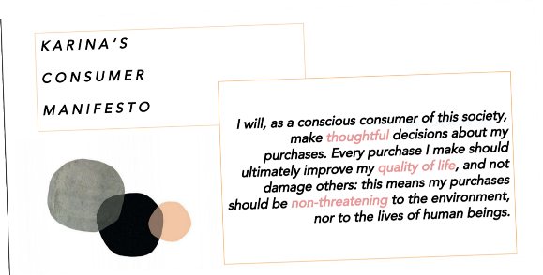

Chapter 10: Tools, Assessments, Standards

Assignment: Circular Sleuths

Fashion brands use assessment tools and certifications as a means of measuring and validating the environmental sustainability of their products – information that can be communicated to their customers.

Discussion prompt: What recommendations do you have for how information about a brand’s circular products could be promoted and shared with a consumer?

Brief: Students should work in groups. Each group should:
- Act as investigators to uncover the assessments tools and certifications of sustainable fashion brands and their circular products
- Compile a list of B-corporations, Cradle to Cradle certified products, and the results of a brand’s Product Lifecycle Assessment (PLA)
- Investigate how this information is shared with the brands’ consumers
- Consider the discussion prompt and suggest recommendations for how information on the environmental sustainability of products could be better promoted and shared with consumers

Deliverable: Each group of students can present their findings in a written news report or a PowerPoint presentation. The results and recommendations can be analyzed in a class discussion or virtual discussion forum.

PART 5: RENEW

Chapter 11: End of Use

Assignment: Remaking Fashion Exhibition

Through upcycling, reclaimed garments can be transformed into new circular ones. Review the concepts of pre-consumer and post-consumer waste (pages 14-15), upcycling/recycling (pages 37-39, 156-160), and the Circular Fashion Model (pages 20-22).

Discussion Prompt: How do we use old, worn, or damaged textiles as a resource, not simply waste?

Brief: Students should work individually and then as a group. Encourage students to:
- Find items in their wardrobe to donate to a class textile recycling donation box
- Utilize the materials collected to create a unique handmade product from the fabrics (for example, old sweaters can be transformed into a new sweater or a covering for a pillow; scraps can be pieced together for a skirt, wall hanging, or quilt)

Deliverable: A student exhibition of the handmade items is an opportunity to introduce circularity to the local community. Students can design an exhibition space using reclaimed materials and provide the narratives behind their own circular processes. An auction of the items may also be held with the funds raised going to charity.

Chapter 12: Collaboration and Innovation

Assignment: What Makes A Circular Leader?

Throughout the term, we have learned about the importance of leaders as change agents in facilitating a sustainable and circular supply chain in the fashion industry.

Discussion prompt: How can you be a circular leader?

Brief: Students should work individually. Each student should research a leader of their choice who is “modeling the way” and moving sustainability/circularity initiatives forward. As a class watch Redefining the Role of the Fashion Industry|Paul Polman|Copehagen Fashion Summit: https://www.youtube.com/watch?v=XVyl3veW7YA.

Deliverable: Each student should create a three to five PowerPoint slide presentation introducing their leader to the class.

Reflection: After watching the video, facilitate a classroom discussion asking students to share their ideas and thoughts about ways to become circular leaders in their own communities and/or on campus.

